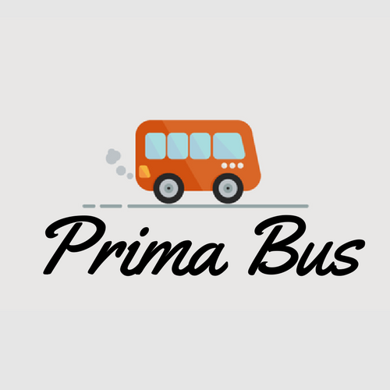

**1.1 Introduction**

**Prima bus** is an application that lets you search, book bus ticket, view your booked tickets and cancel booked tickets. Those who are interested in inquiring about the Bus Type, its Tickets Price, available seats, facility of the bus etc. has to walk to the Booking office. This application makes this easy, now you can enquire about the bus, book bus ticket and cancel your ticket sitting at your home.

A new system is helpful to both employees as well as the customers. New system provides help to the customer as they can inquire about the Bus model, its Ticket price, available Seats, facility of the bus etc. and they don’t need to walk to the office. There is login and password service for employee and Regular customers can use this system .The implementation uses Java which is a set of [computer software](https://en.wikipedia.org/wiki/Computer_software) and specifications developed by [Sun Microsystems](https://en.wikipedia.org/wiki/Sun_Microsystems), which was later acquired by the [Oracle Corporation](https://en.wikipedia.org/wiki/Oracle_Corporation), that provides a system for developing [application software](https://en.wikipedia.org/wiki/Application_software) and deploying it in a [cross-platform](https://en.wikipedia.org/wiki/Cross-platform) computing environment. Java is used in a wide variety of [computing platforms](https://en.wikipedia.org/wiki/Computing_platform) from [embedded devices](https://en.wikipedia.org/wiki/Embedded_device) and [mobile phones](https://en.wikipedia.org/wiki/Mobile_phone) to [enterprise servers](https://en.wikipedia.org/wiki/Enterprise_server) and [supercomputers](https://en.wikipedia.org/wiki/Supercomputer). While they are less common than standalone Java applications, [Java applets](https://en.wikipedia.org/wiki/Java_applet) run in secure, [sandboxed](https://en.wikipedia.org/wiki/Sandbox_(computer_security)) environments to provide many features of native applications and can be embedded in [HTML](https://en.wikipedia.org/wiki/HTML) pages.

**Following are terms used throughout this documentation:**

* **Sign Up: -**

Sign Up is used to create an account for a new customer so that he/she can use the features available in the application such as searching buses from one place to another , to check if seats are available in the bus he/she wants to travel , to book as many tickets he/she wants, to view his/her bookings and to cancel a booked ticket and this can be done by simply clicking on the Sign Up button and providing his/her information to store in the database.

* **Login: -**

Login is the procedure used to get access to an application so that he/she can use the features available in the application such as searching buses from one place to another , to check if seats are available in the bus he/she wants to travel , to book as many tickets he/she wants , to view his/her bookings and to cancel a booked ticket and this can be done by simply clicking on the Login button provided he has a registered User Id and password.

* **Search Bus:-**

Search Bus button is used to search buses for a journey from one place to another. The customer can see all the buses available and chose the bus, which he finds most suitable according to the bus departure time, its fare or bus, type i.e. AC or non-AC. This can be simply done by entering the information of your journey and clicking the Book Ticket button.

* **View Bookings: -**

View Bookings is used to view all the booking details of the customer required that the customer has logged in a has booked at least one ticket in any bus. This can be simply done by clicking on the View Bookings button once you are logged in.

* 1. **System Requirements: -**

**2.2.1 Hardware Requirements Specification:-**

**2.2.1.1 Minimum User Requirement:**

* + - * Processor 2 GHZ
      * RAM 1 GB
      * Disk Space 15 GB Of Free Space
    1. **Software Requirements Specification:-**

**2.2.2.1 Minimum User Requirement:**

* Net Beans IDE 8.1 or more
* MySQL

**2.3 DATA FLOW DIAGRAM: -**

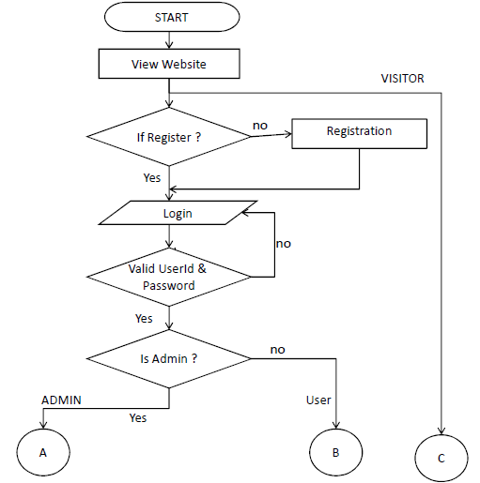

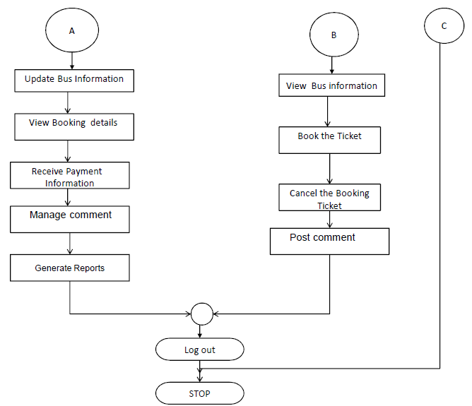

**2.5 Data Dictionary: -**

**Table Name: user**

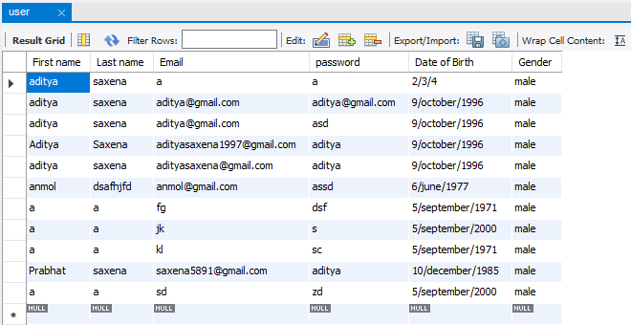

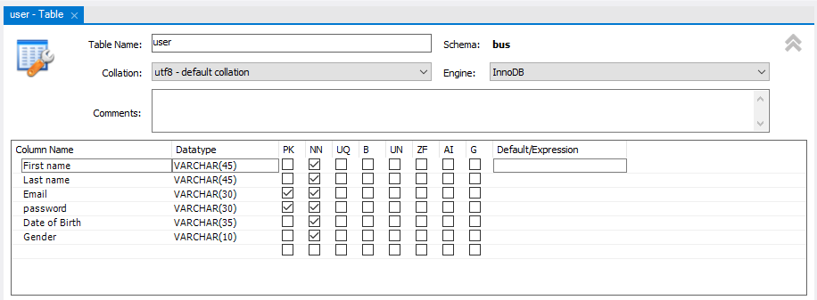

**Table Name: available bus**

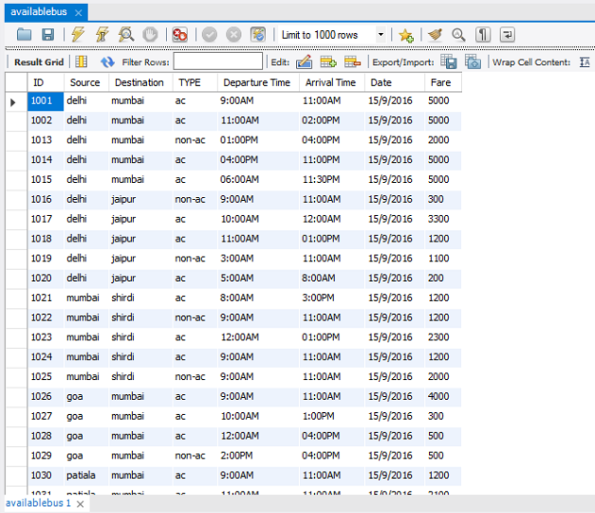

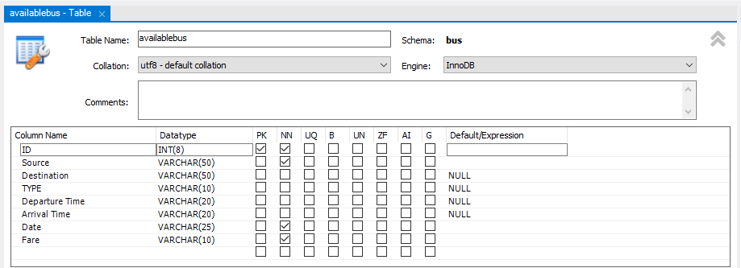

**Table Name: reserve**

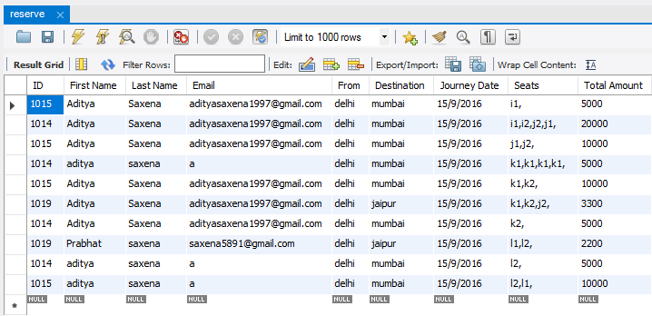



**2.6 Output Screenshots: -**

**2.6.1 Sign Up: -**

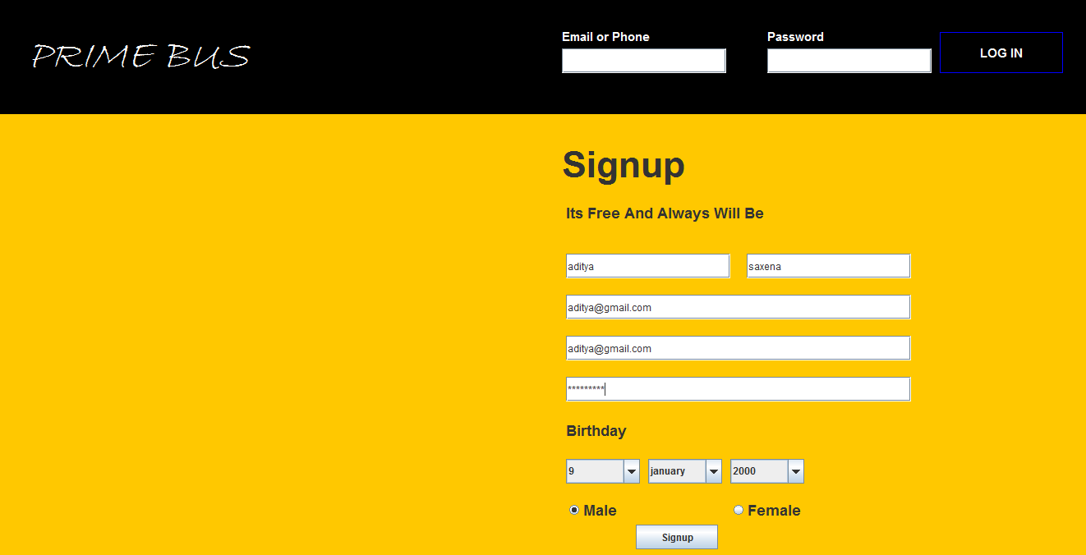

**2.6.2 Log in: -**



**2.6.3 Search Bus: -**

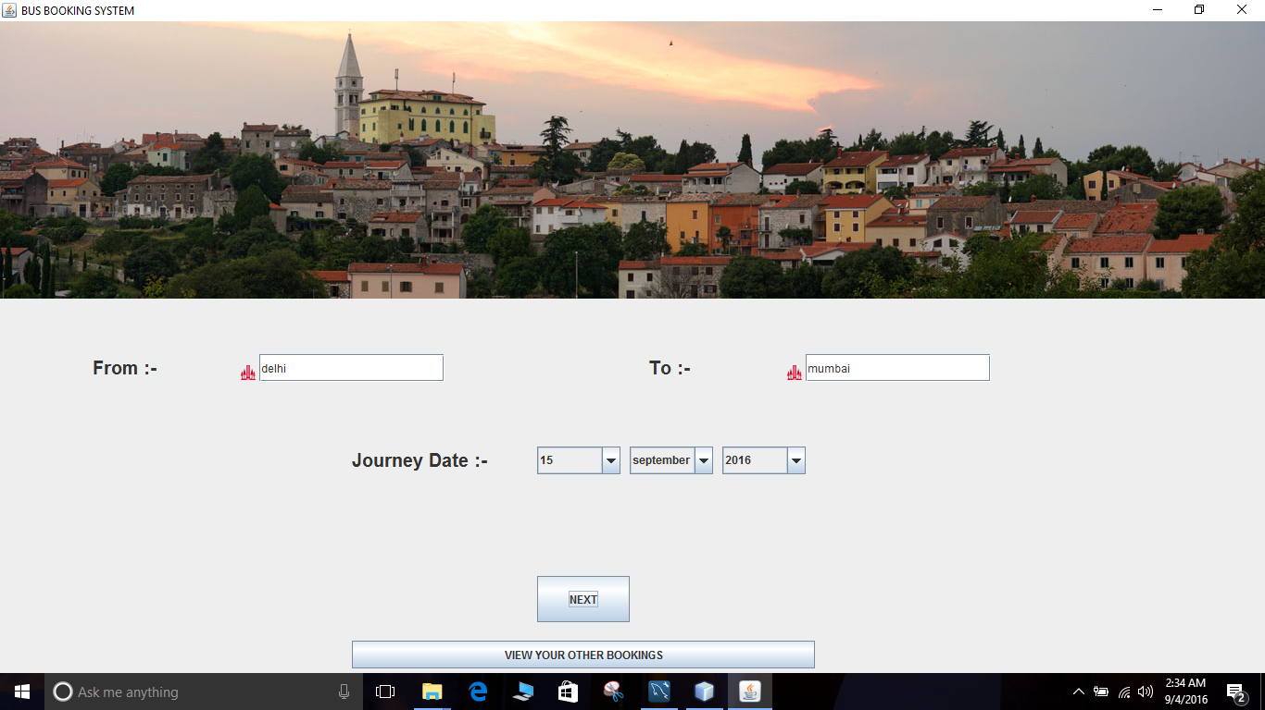

**2.6.4 Buses Available: -**

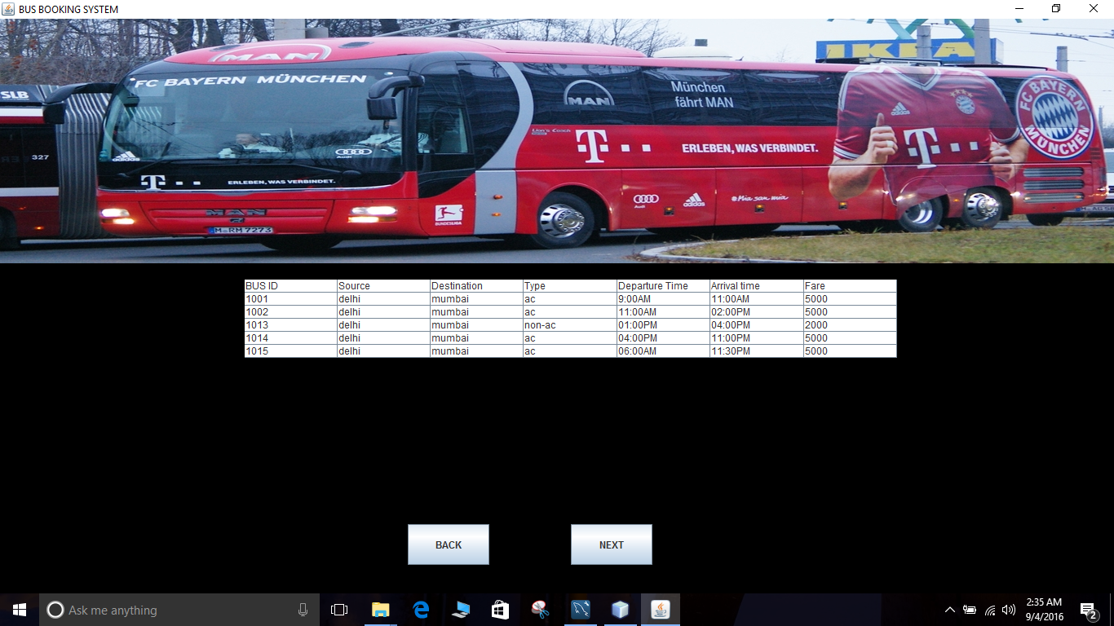

**2.6.5 Selecting Seats: -**

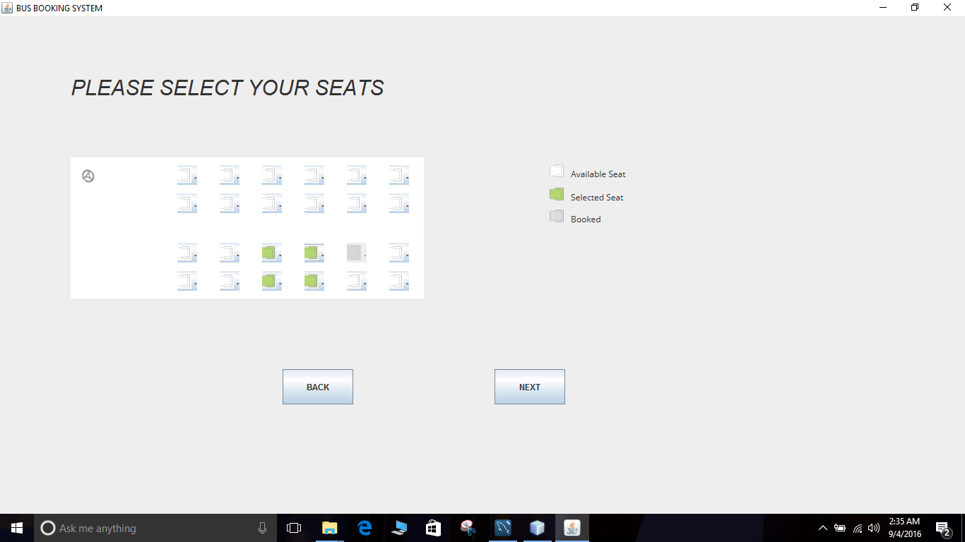

**2.6.6 Booking Confirmation: -**

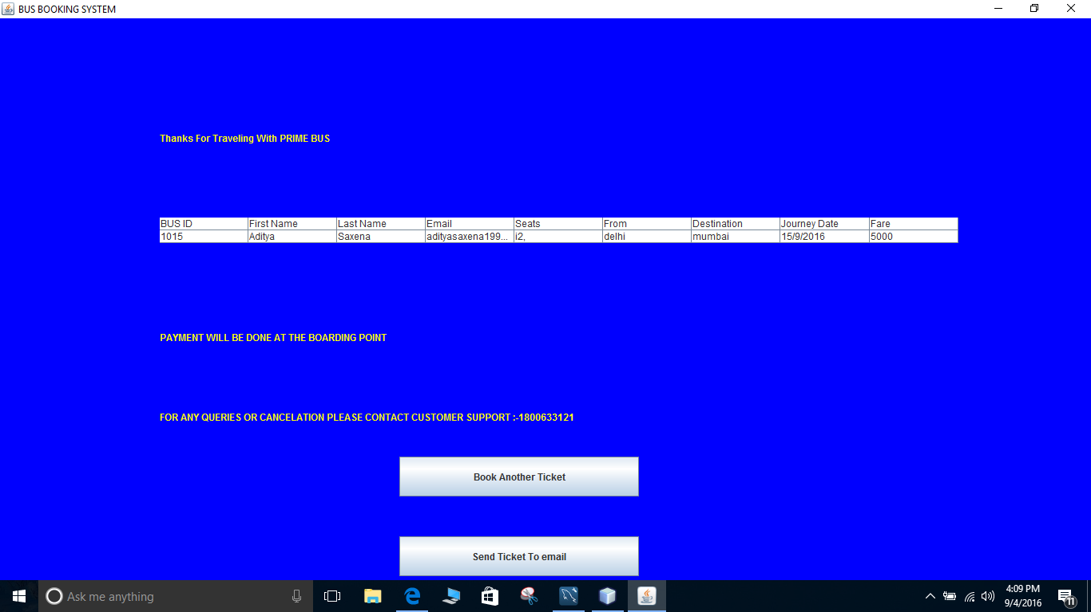

**2.6.7 View Booking Details: -**

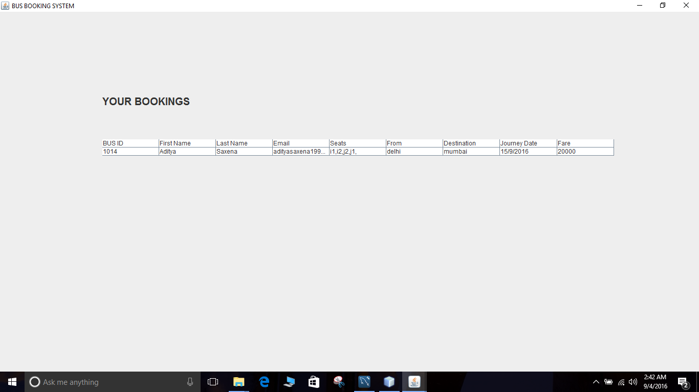

**2.6.8 Send Ticket to Email Id: -**



**2.6.9 View Booking Details: -**

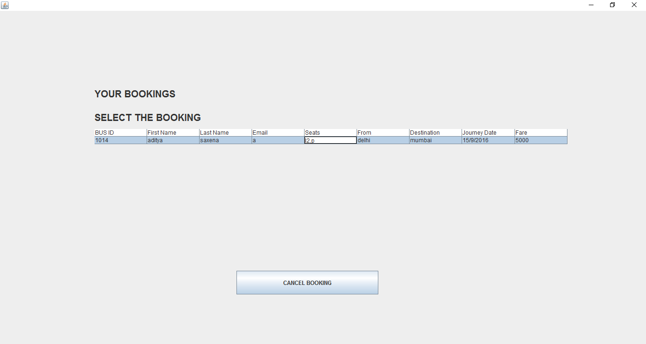

**2.7 FUTURE ENHANCEMENT: -**

* Creating an Android/IOS application .
* Inclusion of METRO UI for desktop application
* Linking our booking system with other centralized bus services
* GPS tracking of the bus using special link provided to users.
* Cloud database
* Website
* More data for visitors

**3 BIBLIOGRAPHY: -**

During the development of my system, I have taken the reference from Books and journals, which I would like to mention in this section.

These books acted as my tutors during the system development.

### JavaBeans: Developing Component Software in Java by John Osborn

### Java Network Programming by  ‘O'Reilly & Associates

### The Java Developer's Resource by Elliott Hardy

Besides these I was referring the online manuals from the sites.

www.google.com

www.GSRTC.com

www.neeta.com

www.gujrat.com

www.paswanath.com